Std_Name…………………………………………Fokwen Bechem, Emmanuel

Std_Number……………………………………..293370

Course_Code…………………………………… MIS500-Foundations of Data Analytics

Module4-………………………………………… Option2-Hypothesis testing using R software

Below is the sample code for the hypothesis test of student performance before and after tutoring

group_by(my_data, group) %>%

+

+ summarise(

+

+ count = n(),

+

+ mean = mean(scores, na.rm = TRUE),

+

+ sd = sd(scores, na.rm = TRUE)

+

+ )

> # Compute Unpaired Two Sample t-test

>

> res <- t.test(tScore_before, tScore_after, var.equal = TRUE)

>

> res

> # Compute independent t-test

>

> res <- t.test(scores ~ group, data = my_data, var.equal = TRUE)

>

> res

>

> #test whether the average score before score is less than the average after score, type this:

>

> t.test(scores ~ group, data = my_data,

+

+ var.equal = TRUE, alternative = "less")

***The below screenshots show the execution of the code in R studio***

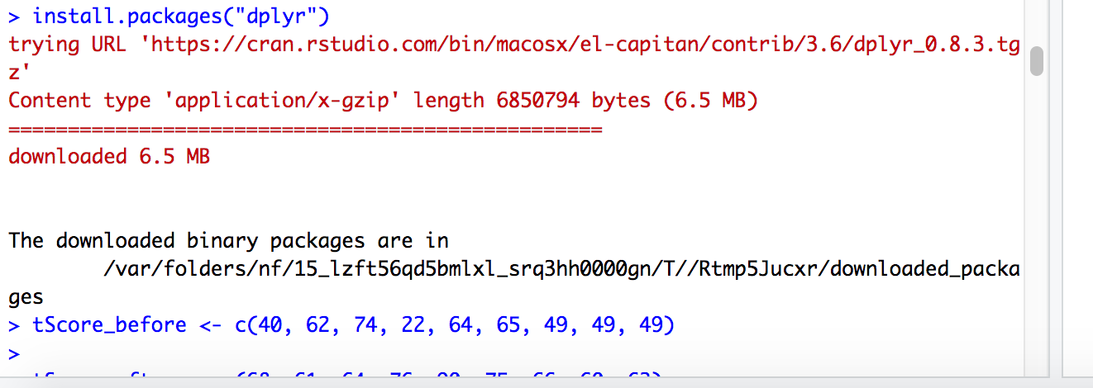

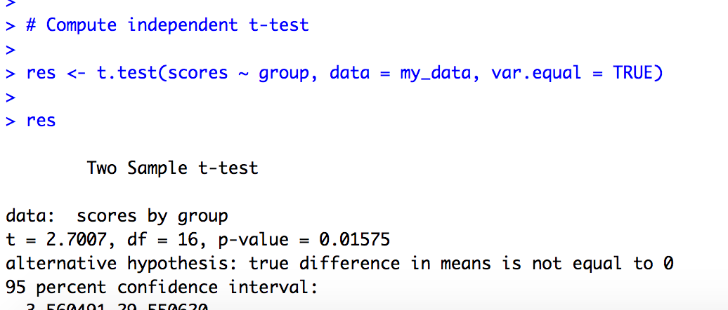

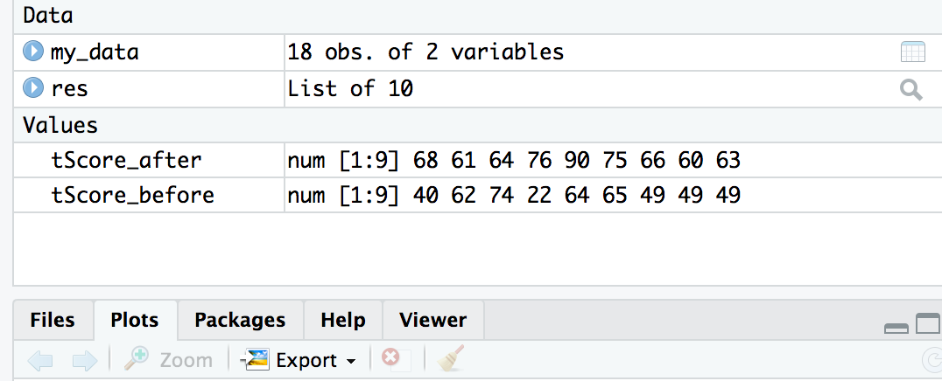

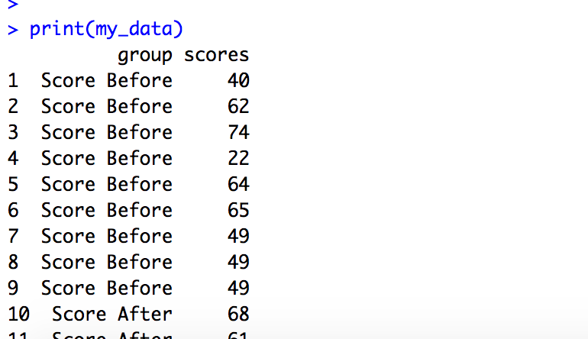

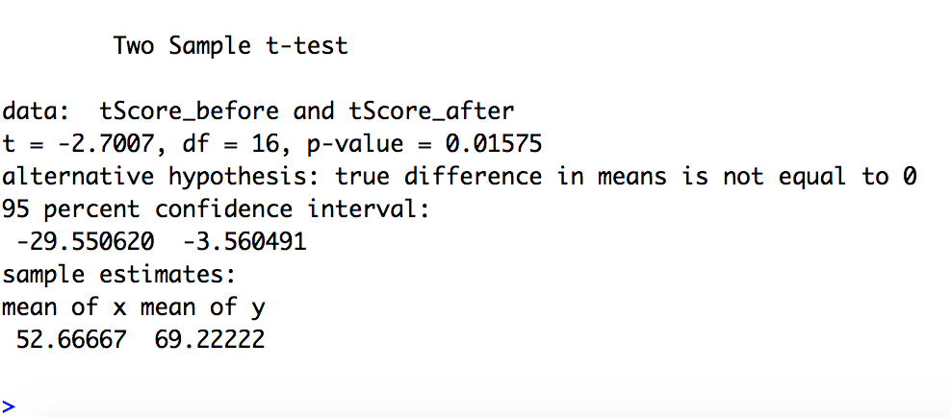

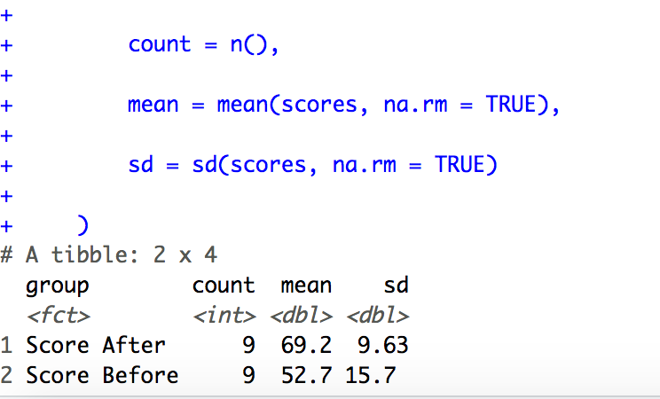

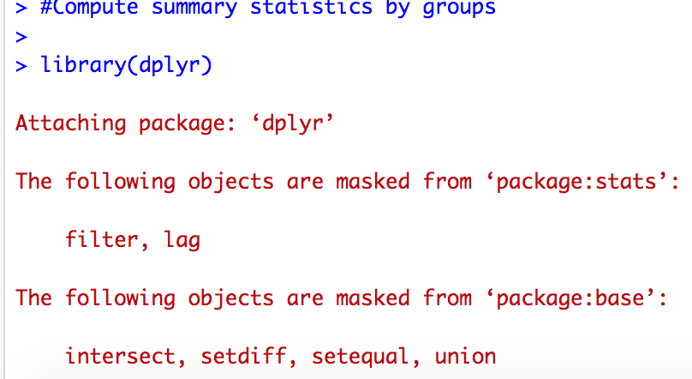



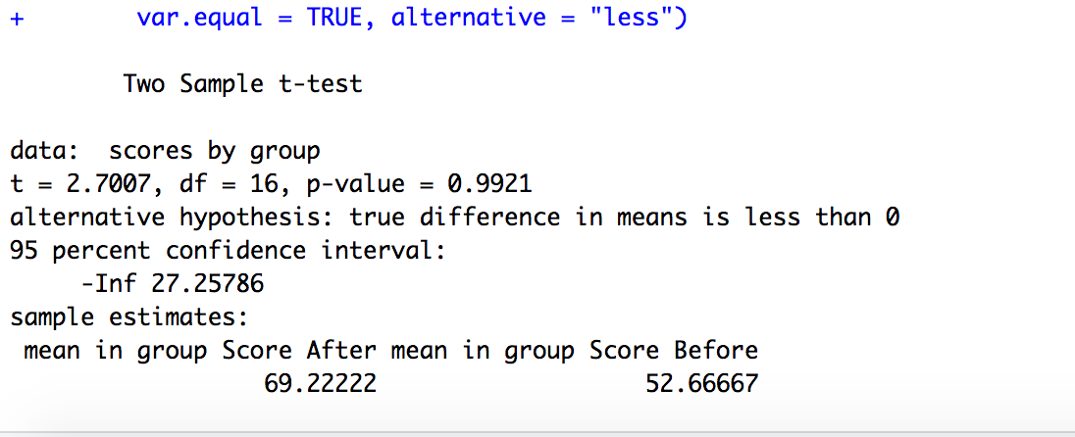

References;

Dietrich et all(2015). *Data Science and Big Data Analytics-Advanced Analytical techniques-Hypothesis testing*

Davies, T.(2016). *The Book of R- A First in Programming and Statistics*